**Unit: Lowell and the Industrial Revolution**

**Author:** Mary Price Maddox: High School, Acton, MA

**Lesson Topic:** Human-Environment Interaction & Technology

**Grade Level:** Middle School/High School

**State Standards:**

**Class Time:** 90 minutes

**Objectives:**

* Students will learn how to transfer and convert energy from a natural source into power to perform a basic function.
* Students will apply basic engineering skills to design and place basic machines (bevelled gear, belt) to perform a function.
* Students will understand how an abundance of natural resources was necessary for the industrial revolution
* Students will understand the importance water power played in the development of Lowell.

**Prerequisite knowledge/Background Information:**

**Materials:**

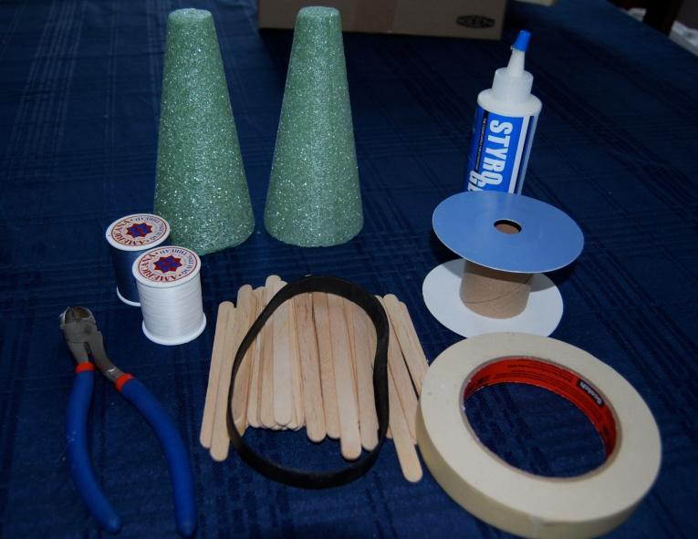

* glue (glue guns may work faster)
* styrofoam cones
* masking tape
* thread spools
* popsicle sticks
* ribbon spool
* large rubber band
* wire clippers (scissors will work too)
* one inch styrofoam (not pictured)
* precut dowels (not pictured)

**Procedure:**

1. Students will be divided into teams. Each team will be given a shoe box containing the same supplies.
2. Teams will use the materials to design and build a basic grist mill (saw mill may be substituted for a more challenging project). A competitive element may be added by awarding points to the first completed or to be best project completed in the allotted time. Projects should be reasonably contained in the space of the shoe box. They may build above the rim or attach a water wheel to the outside of the box so long as the construction remains in scale with the rest of the project.

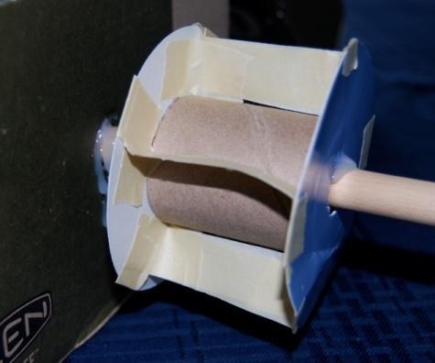

1. Projects should include both a **bevel** **gear** and a **belt**.

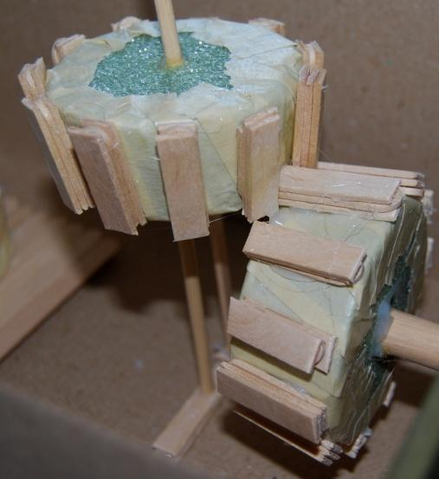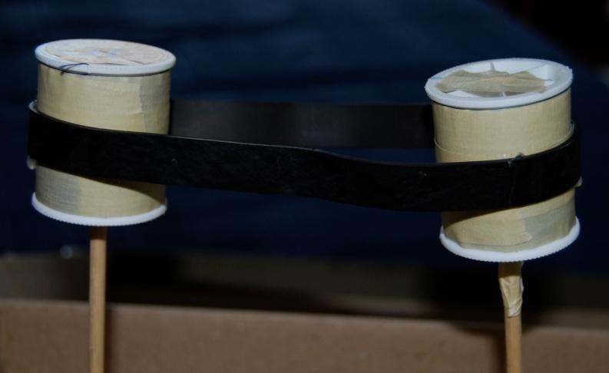

1. Each team will be required to present its project to the larger group. Some questions / thoughts to consider in the presentations/discussions:
   * 1. Identify and explain all the elements of you project from the source to the product.
     2. How and why did you place and build your bevel gear and belt?
     3. Which was easier to build: the bevel gear or the belt? What are the implications for an early mill builder?
     4. Do they perform an identical function? What was the easiest method to change the direction of the power? Which do you think will transfer power more efficiently?
     5. Which was harder building the elements or engineering the design/layout?
     6. What elements might you have added to the box to make it easier to build or more advanced in its function?

**Assessment**

Teams will be evaluated on:

* their ability to work together
* the creativity and accuracy of design
* craftsmanship and durability
* thoroughness and accuracy of presentation
* inclusion of required elements
* Bonus Points will be awarded for projects that actually function.