**Unit: Lowell and the Industrial Revolution**

**Author:** Debra Sands: 7th Grade, New York

**Lesson Topic:** Labor-Mill Life

**Grade Level:** Middle School

**State Standards:**

**Class Time:** 45 minutes

**Objectives:**

* Students will understand the differences between farm life and mill life
* Students will display an understanding of what the average day of a mill worker was.
* Students will be able to determine between opportunity and dead end.

**Prerequisite knowledge/Background Information:**

Students have already learned about what the average day in the mill was like.

In this assignment, the students will have to decide whether they would rather their own kids to stay home and work on the farm, or go to Lowell and work in a mill.

**Materials:**

* Prerquisite knowledge
* Pro/Con Worksheet

**Procedure:**

1. Explain to the class that today they need develop an opinion and defend it by showing the complexity of an argument.
2. Pass out the attached worksheet
3. When the students are done, have them present their opinions to the class.

**Assessment**

Name: ______________________________ Date: _____________

**Where Should You Work?**

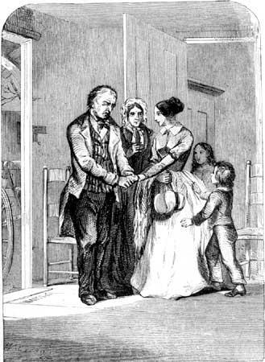

**Background:** You and your family are currently a rural town. Everyone in your family is helping on the small farm that your family owns. Though surrounded by family and friends, you have an opportunity to go to the local city and work in one of the mills. Knowing that this could be a life changing decision, you need to come up with a list of pros and cons to help make the best decision.

**Directions:** Look to see which position you have on the issue of whether or not Ms.

Sands should leave the farm and go work in one of the mills. Come of with

three GOOD reasons why she should do as you suggest and not the opposite.

You live and work on a farm and want to stay in the village. 

c Come up with three good reasons why she should stay and three

separate reasons why she should not leave.



Though you still live in the village, you have several family members who live

in the city and work in the mills and you see no reason why you shouldn’t

join them. Come up with three good reasons why you should

go to the city as well and three separate reasons why she should not stay on the

farm.

**Three reasons why I should stay or go are:**

1.) _____________________________________________________________________

_____________________________________________________________________

_____________________________________________________________________

2.) _____________________________________________________________________

_____________________________________________________________________

_____________________________________________________________________

3.) _____________________________________________________________________

_____________________________________________________________________

_____________________________________________________________________

**Three reasons why the other side is wrong are:**

1.) _____________________________________________________________________

_____________________________________________________________________

_____________________________________________________________________

2.) _____________________________________________________________________

_____________________________________________________________________

_____________________________________________________________________

3.) _____________________________________________________________________

_____________________________________________________________________

_____________________________________________________________________