M3: DSP Technology & Practices

**(Dr. Aaron Noyes, Sr. Scientist, Pfizer, Adjunct Professor at UMass Lowell)**

Continuous operation of downstream processing of biologics is drawing widespread interest from industry, academia, and regulatory bodies. The benefits of continuous downstream processing include enhanced flexibility and scalability, improved volumetric productivity, decreased cycle times, and reduced capital costs. Conventional biopharmaceutical production has been predicated on batch operation and the shift to continuous processing must leverage the pre-existing technical understanding of separation processes while integrating an evolving body of new technological, engineering, and regulatory knowledge. The marriage of disposable technology with continuous operations offers additional complexity. The conversion of batch processes to continuous operations requires an understanding of the underlying separation science, equipment design, and control strategy. In this module, we will use the fundamental science of batch operations to examine options for converting common unit operations into continuous processes. A detailed analysis of engineering challenges and scale-up strategies will be undertaken for unit operations including clarification, chromatography, and tangential flow filtration. Many of the available solutions are designed to be disposable and the implications of single-use vis-à-vis reusable equipment will be carefully considered. In some instances, novel enabling technology (e.g. acoustic wave separations) offers the potential to supplant conventional unit operations and for such disruptive technology, the relevant technical aspects will be explored.

Continuous downstream processing starts with a single unit operation and can extend to encompass the entire downstream process train. The seamless aseptic linkage of adjacent unit operations poses challenges for equipment design, liquid handling, and process control. These issues are complicated by regulatory questions regarding batch definition, consistency, and product quality. These topics and their intersection will be developed through consideration of fully integrated continuous downstream processes. Case studies will be used as appropriate to provide context and highlight particular insights.

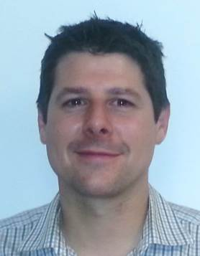

Aaron Noyes is a Senior Scientist in the Purification Process Development group at Pfizer Biotech in Andover, MA and part of the adjunct faculty in the department of Chemical Engineering at UML. Aaron has over 15 years of experience in the biopharmaceutical industry, with most of that time focused on developing purification processes and scaling up biologics, including mAbs, recombinant proteins, ADCs, vaccines, cell therapies, and viral vectors. Prior to Pfizer, Aaron developed chromatography products and filtration applications at Millipore Corporation. Aaron has contributed to the scientific community through more than 20 publications and presentations, reviewing articles for several journals, and playing an active role in the Biochemical Technology division (BIOT) in the American Chemistry Society.

Aaron received a B.S in Biochemistry from the University of Massachusetts at Amherst and a M.E in Biotechnology Engineering from Tufts University. For his Engineering Doctorate in Biochemical Engineering, Aaron attended University College London where his thesis research focused on developing modular, high throughput tools to improve the production of polysaccharide vaccines. Aaron has also taught graduate classes in protein purification at Tufts University and Northeastern University.