M2: USP Technology & Practices - Equipment and Practices

**(Sadettin Ozturk, Mass Biologics Lab)**

Continuous culture provides advantages over traditional batch operation such as enhanced productivity and product consistency. Even though it is more complicated than a batch operation, the technology has matured over the years and there are many options available to the users. This module is designed to introduce the basic concepts of continuous culture, introduce different cell retention systems available, and provide theoretical understanding of cell physiology during continuous operation.

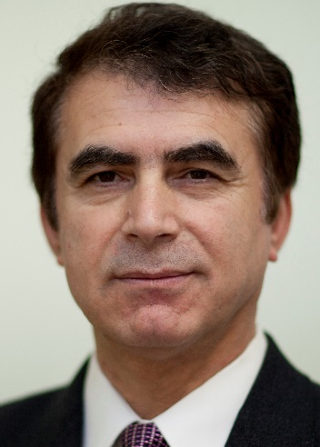

Dr. Sadettin Ozturk is currently the head of process and analytical development at Mass Biologics in Boston, USA. He has had a long career in cell culture process development, technology transfer, product licensing, and commercial manufacturing. His early contributions to the field focused on applying chemical engineering principles and process control strategies to the optimization and scale-up of cell culture processes. The scope of his work has expanded over the years, but it has always been focused on advancing cell technology. He was responsible for the development of numerous cell culture based processes and novel technologies that helped not only the companies that he worked for (Verax, Bayer, GlaxoSmithKline, and Johnson & Johnson), but contributed to the rest of the field through his numerous presentations and publications. Sadettin led process development activities and played a key role in the licensing and commercialization of two monoclonal antibodies, Stelera, and Simponi. In addition, he transferred and supported the commercial manufacturing of Kogenate and BeneFix. Sadettin has published numerous research articles, given presentations, delivered keynote lectures, and edited books. He is a member of several societies including ESACT, American Association for the Advancement of Science, New York Academy of Sciences, American Chemical Society, and American Institute of Chemical Engineering. Sadettin is involved in these scientific organizations and other community activities by serving on their Scientific Advisory Boards and organizing meetings and sessions. He has served Biochemical Technology (BIOT) division of American Chemical Society as the Division Chair, and then as a Councilor. He co-authored a well-respected book in the field entitled Cell Culture Technology for Pharmaceutical and Cellular Therapies. Sadettin also serves on Editorial and Review Boards for several journals and other publications.