M10, ICB, Flowsheeting & USP Modeling

**(Shaun Galbraith, Department of Chemical Engineering, University of Massachusetts Lowell)**

Process models are fundamental to the development and optimization of emerging technologies, saving time and money by allowing more targeted design of experiments. This module is designed to demonstrate how process models, specifically flowsheet models, are used describe processes and perform valuable simulations to ensure better running of real processes. Specific bioprocess models are introduced and their application to biomanufacturing is discussed. In this program, participants will learn about:

* Flowsheet modeling: a real-time demonstration applied to oral-dosage drug manufacturing
* Bioprocess modeling approaches
  + Macro (intercellular) kinetic models
  + Micro (intracellular) metabolic flux balance analysis
  + Glycosylation modeling
* Multiscale modeling: how to combine the macro and micro scale models

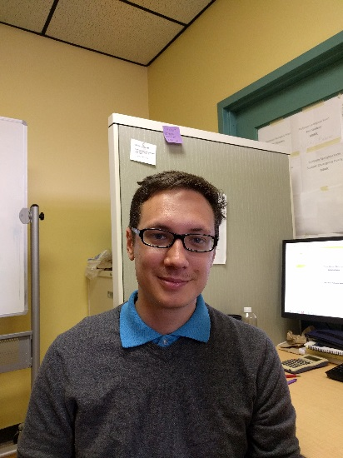

Dr. Shaun Galbraith is currently a post-doctoral fellow at the University of Massachusetts Lowell. His research focuses on the development of process models for particulate systems. The scope of this research is far-reaching and ranges from manufacturing processes for solid-dosage pharmaceuticals to nutrient recovery from wastewater addressing the issue of phosphorus scarcity. He has also performed fundamental experimental work investigating crystal growth rate dispersion. He is currently working on developing flowsheet models for solid drug manufacturing processes to be used in case studies with industrial and regulatory collaborators and modeling of continuous virus production in a mammalian cell bioreactor.