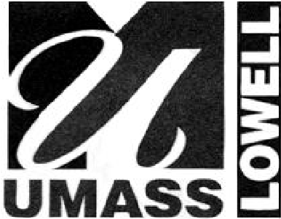
Glenn MacDonald University of Massachusetts Lowell
Director One University Avenue tel. 978.934.2618
Lowell, Massachusetts 01854 fax 978.934.4018

ENVIRONMENTAL HEALTH AND SAFETY

EHS Chemical & Biological Product(s) Transfer Approval Form

This form is for the one time approval for shipment of chemical or biological product(s) that are intended to be transferred from offsite locations to the University of Massachusetts Lowell (UML).

UML will accept chemical and biological products that have been reviewed and approved by Environmental Health and Safety and Department Administration.

Where are products being shipped from: (Name): _________________________________________ Address:__________________________________________________________________________
I(name)_______________________________,(title)____________________________________, (agency/company name)_________________________ on this date of __________ have read the information herein and have the authority to sign for all responsibilities and liabilities (implied and expressed) regarding acceptance in the lab, safe use, and compliant disposal of the transferred products.
All approved products must be packaged and shipped in accordance with applicable D.O.T. Hazardous Materials and IATA Dangerous Goods regulations. UML will not accept items transferred in personal vehicles. It is incumbent upon the shipping agency to assure that all applicable regulations and safety practices are regarded.

Approved products must be shipped to:

Address:
University of Massachusetts Lowell
Hazardous Materials Receiving Stockroom
201 Riverside Street
Lowell, MA 01854

Attn: John Freeman
Tel#: (978)934-2632
Upon receipt, chemical and biological items are tracked, inventoried, and delivered by EHS personnel to labs on campus. Please identify the location where products will be used and stored on campus.

(Building, Lab Number, Contact#) ___________________________________________________________

ENVIRONMENTAL HEALTH AND SAFETY

Please list products intended to be shipped to UMass Lowell:

Product/Chemical Name, Manufacturer, Amount (Volume/Weight #of-containers)
_________________________________________________________________________________ _________________________________________________________________________________
_________________________________________________________________________________ _________________________________________________________________________________ _________________________________________________________________________________
_________________________________________________________________________________ _________________________________________________________________________________ _________________________________________________________________________________
_________________________________________________________________________________ _________________________________________________________________________________ _________________________________________________________________________________
_________________________________________________________________________________ _________________________________________________________________________________ _________________________________________________________________________________
_________________________________________________________________________________ _________________________________________________________________________________ _________________________________________________________________________________
_________________________________________________________________________________
_________________________________________________________________________________

Please return this document via e-mail to Glenn_MacDonald@uml.edu or Kathi_Lamond@uml.edu for approval.

Reviewed and Approved by (Signature)
Date:

