25Live – USING THE ONLINE FORM
*Note: Best if accessed via Google Chrome or Firefox web browsers
Step | Action
Name:

Note: Do not include personal identifiers in event name, such as a person’s name, unless they are a guest speaker or performer.
Title:
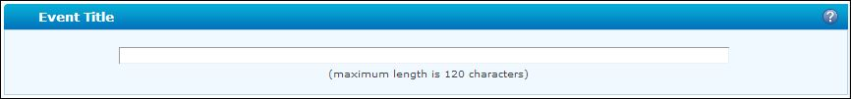

The title can be a copy of the Event Name or it can be an extended, more formal name. This is what will be displayed on the UML Calendar.
Note: You have the ability to create favorites for many fields, Event Type, Locations, Resources, Organization etc. By clicking on the star next to the value after it has been selected for a field, it will be designated a favorite. Upon your next login, all “favorited” items will appear as preferences (“Your Starred…”) and will make submitting the form much more efficient (rather than having to search for items).

Type:
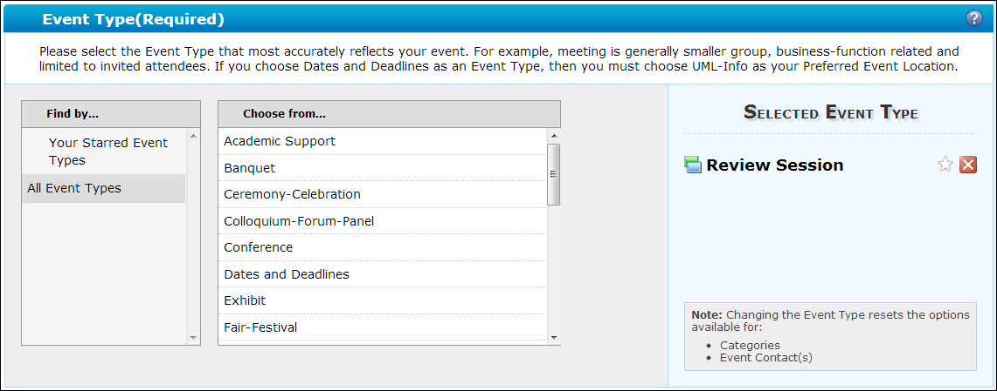

To search event types before you have starred event types created, click All Event Types, and click on the appropriate event type in the “Choose from…” menu. Selected type will appear on the right.
Please make sure ACTUAL event time is entered (not including setup/breakdown). You may add setup/breakdown by clicking on the blue links for setup and takedown or CES schedulers will add these to your reservation based on criteria you’ve selected, if necessary.

Note: Adding or neglecting to add setup/breakdown may affect availability, as total reservation time will change.

To create a reservation with RECURRING dates, please use the Repeats Ad Hoc feature in the dropdown. A calendar will appear, and you may add additional dates by clicking the corresponding dates on the calendar. A list of dates will form for your review.

Date and Time:
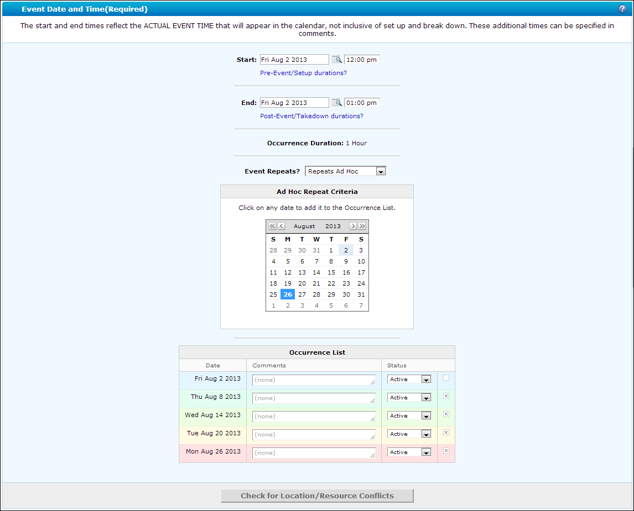
Add expected number or make your best estimate. This will help guarantee the location that best fits the event.

Head Count:
To search locations, click Public Searches, choose search from list, and click on the desired location in the Choose from… menu. Selected type will appear on the right.

If you use a room code from memory, we cannot guarantee it will be a reservable space, only those identified through the public searches are confirmed as “bookable”.

Locations:
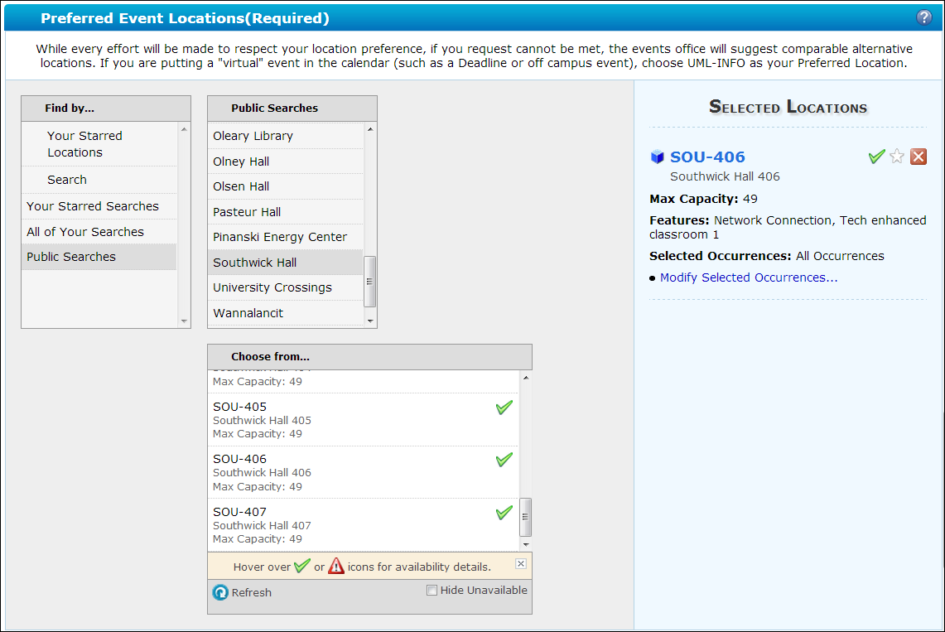

Conflicts will be noted by a red triangle. To review conflicts, simply hover over the red triangle, and then hover over the conflict. It will give you the name and time of the conflict reservation.

Rooms with a green check are currently available to assign.

Note: An available room must be selected to save your request.
You may notice that not all days are conflicts if you create a reoccurring reservation. You can deselect the conflict dates and choose an alternate location for those dates if you wish, by unchecking the Assign checkbox for the conflict dates, and assigning an additional space to the reservation.

Once the additional space is added, make sure it is only assigned for the dates needed.

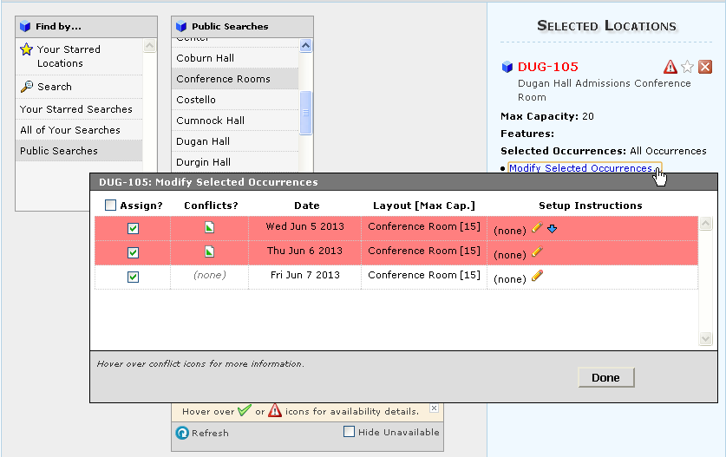
Selected locations must have green checkmarks in order to save the reservation; otherwise it will run into a conflict upon saving.

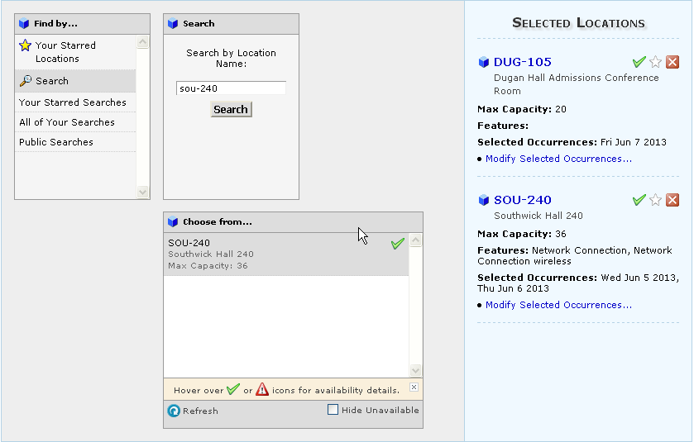
Select the primary department requesting the reservation by clicking Search and typing a keyword of the department name. Once you locate the dept. name, add it by clicking on it in the Choose from… box.

Department Sponsoring:
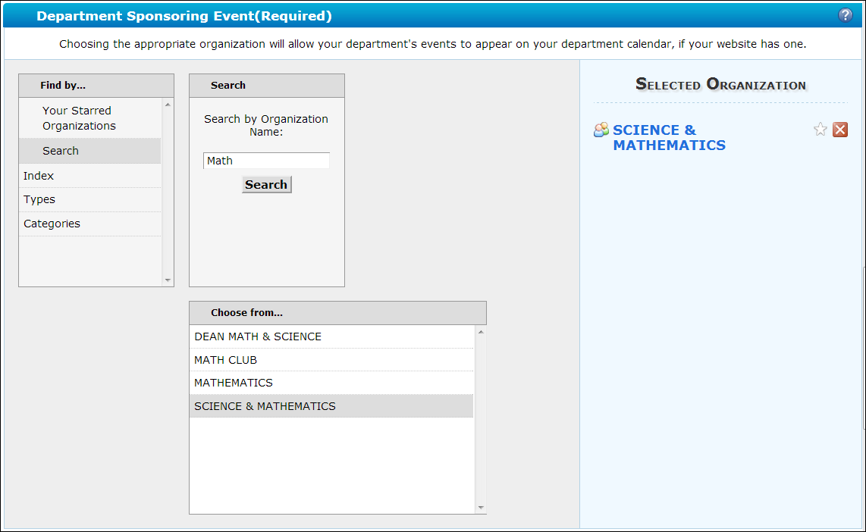
Please include any and all information in regards to event/meeting setup in this section. If you have any questions for the scheduler, they may also be included in this section.

Comments:
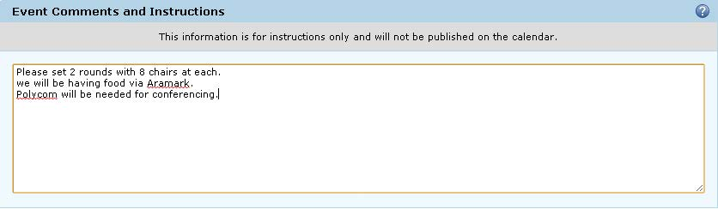
You can select various contact roles for your reservation, including “Requestor”, “Scheduler”, and “Contact-Day of Event”. These choices may vary depending on Event Type. You can select a contact by clicking Search, entering the contact’s last name, then clicking Search.

Contact Roles:
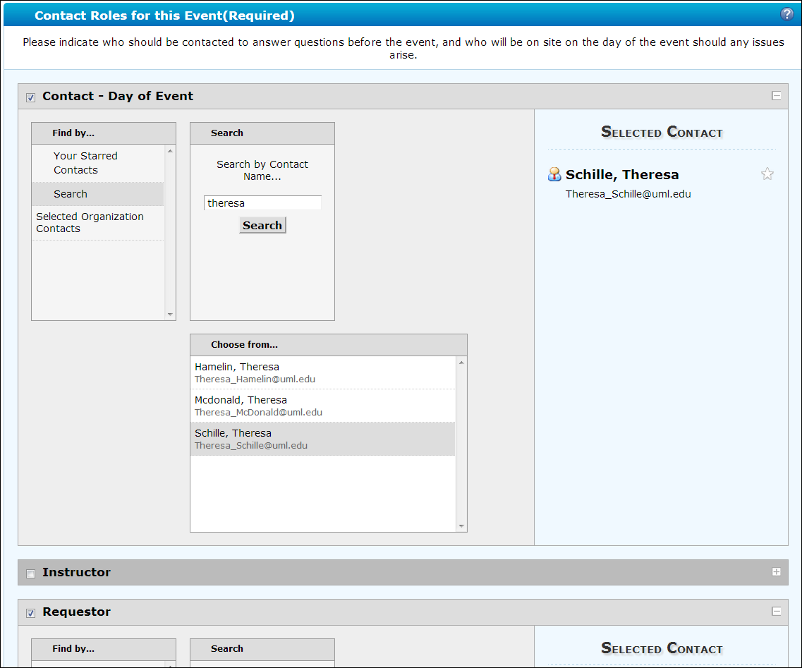
 | Click Next to continue on to select resources.
Select Categories. Select Book It

Note: These are the only resources requestors are allowed to select. If you need additional resources, please include that information in the comments section.

Resources:
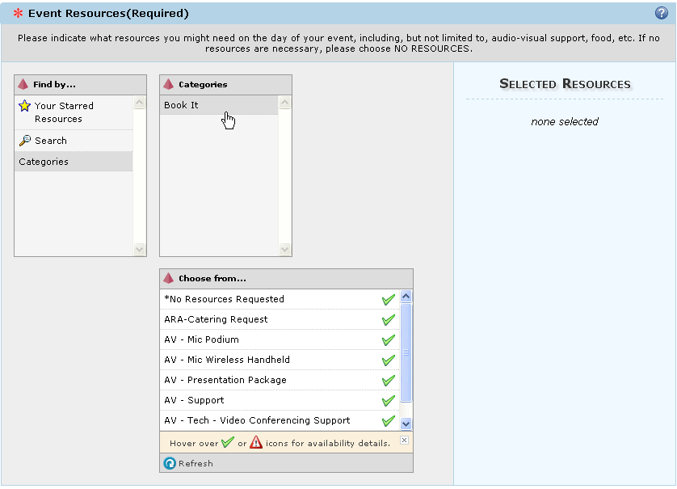
You may either click Finish at this point if you have no promotional info to enter. The event will be saved and routed to CES for approval.

You may also choose to click Next which will bring you to the final page to input promotional information, assign categories such as “Do not Publish”, and add additional organizations.

This field is for PROMOTIONAL information, and WILL DISPLAY ON THE PUBLIC CALENDAR – DO NOT put setup instructions in this field. Anything submitted in this field is subject to review by Public Affairs & CES.

Description:
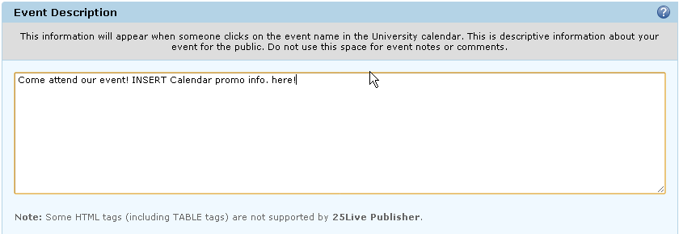
*The important categories for requestors will be “Do Not Publish to Web” which hides the event from the public calendar. CES schedulers will review any checked category for accuracy and modify as needed

Categories:
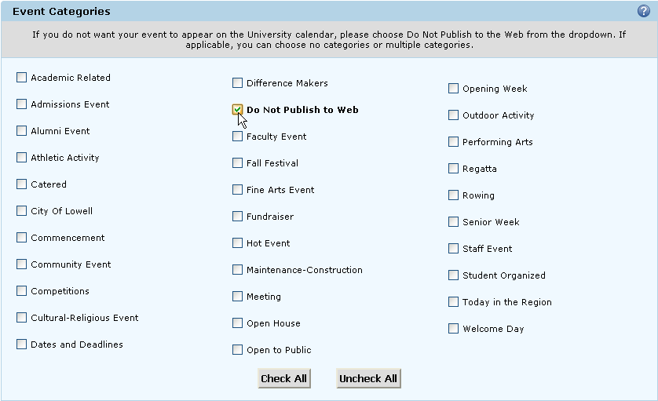
This field is NOT required. Use as needed. If more than one department is co-hosting an event, you can add the additional organization here by using the same process as Sponsoring Organization

Organizations:
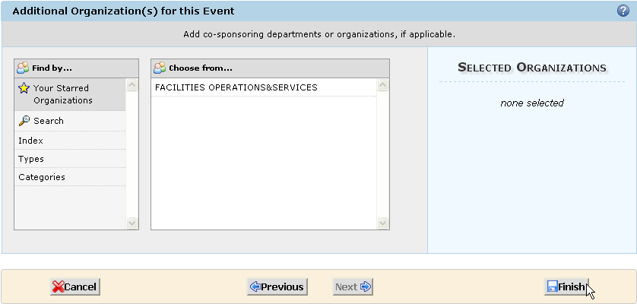

Click Finish to save event. It will be routed to CES for approval, and official reservation confirmation will be e-mailed to requester once approved. Please allow up to 2 business days for response

